 VISVESVARAYA TECHNOLOGICAL UNIVERSITY, BELAGAVI - 590018



**A MINI-PROJECT REPORT ON**

**“NASAA-COSMETICS”**

**Submitted in partial fulfillment of the requirements of the award of degree of**

**BACHELOR OF ENGINEERING IN**

**COMPUTER SCIENCE & ENGINEERING**

**Submitted By:**

**MOHAMMED SAQLAIN [4VV18CS081]**

**NASHRA TANSEER [4VV18CS088]**

**UNDER THE GUIDANCE OF**

**Dr. Aditya C R Ms. Harshitha K**

**Assoc. Prof Asst. Prof**

**Dept of CSE Dept of CSE**

**VVCE, Mysuru VVCE, Mysuru**



**2020-2021**

**DEPARTMENT OF COMPUTER SCIENCE AND ENGINEERING VIDYAVARDHAKA COLLEGE OF ENGINEERING**

**MYSURU-570002**

Vidyavardhaka College of Engineering Gokulam 3rd Stage,

Mysuru-570002

**Department of Computer Science and Engineering,**

**CERTIFICATE**

This is to certify that the mini-project report entitled **“NASAA-COSMETICS”** is a bona fide work carried out by **MOHAMMED SAQLAIN** (4VV18CS081), **NASHRA TANSEER** (4VV18CS088) students of 5th semester Computer Science and Engineering, **Vidyavardhaka College of Engineering, Mysuru** in partial fulfillment for the award of the degree of **Bachelor of Engineering** in **Computer Science & Engineering** of the **Visvesvaraya Technological University, Belagavi**, during the academic year **2020-2021**. It is certified that all the suggestions and corrections indicated for the internal assessment have been incorporated in the report deposited in the department library. The report has been approved as it satisfies the requirements in respect of mini-project work prescribed for the said degree.

**Signature of the Guide Signature of the Guide Signature of the HOD**

**(Dr. Aditya C R) (Ms. Harshitha K ) (Dr. Ravi Kumar V) Name of the Examiners Signature with Date**

**1)**

**2)**

**ACKNOWLEDGEMENT**

The Mini-project would not have been possible without the guidance, assistance and suggestions of many individuals. I would like to express our deep sense of gratitude and indebtedness to each and every one who has helped me to make this project a success.

We heartily thank our beloved Principal, **Dr. B Sadashive Gowda** for his whole hearted support and for his kind permission to undergo the mini-project.

We wish to express our deepest gratitude to **Dr. Ravi Kumar V**, Head of Department, Computer Science and Engineering, VVCE, for his constant encouragement and inspiration in taking up this mini-project.

We gracefully thank our mini-project guides, **Dr. Aditya C R**, Associate Professor and **Ms. Harshitha K**, Assistant Professor, Dept. of Computer Science and Engineering for their encouragement and advice throughout the course of the mini-project work.

In the end, we are anxious to offer our sincere thanks to our family members and friends for their valuable suggestions and encouragement.

**MOHAMMED SAQLAIN [4VV18CS081]**

**NASHRA TANSEER [4VV18CS088]**

**ABSTRACT**

It is a database dependent application which basically provides detailed records about the

NaSaa-Cosmetics store. It will be in synchronization with the real time updates via internet.

The application is made using JSP and consists of a GUI. There will be many forms which will serve the purposes of different functions and features to be implemented. Any query by the

admin will lead to changes in the database and will be saved so that the user can track it even afterwards. A user can access the database for different purposes like viewing the current status of a particular product, editing that, etc.

A registered user will also have an option to check the availability of the products and any changes will be automatically viewed. He/she will even be able to view the date of purchase and expiry of the product as in which have been bought from the source.

**TABLE OF CONTENTS**

|  |  |
| --- | --- |
| **CHAPTERS**  **1. INTRODUCTION** | **Page No** |
| 1.1 Overview | 1 |
| 1.1 Objectives | 1 |
| **2. HARDWARE AND SOFTWARE REQUIREMENTS** |  |
| 2.1 Hardware requirements | 2 |
| 2.2 Software requirements | 2 |
| **3. DESIGN AND IMPLEMENTATION** |  |
| 3.1 schema diagram | 3 |
| 3.2 Entity relationship diagram  3.3 Introduction to Eclipse  3.4 Introduction to Mysql | 4  5  5 |
| 3.5 Modules, Tables and their description | 6&7 |
| **4. RESULT** |  |
| 4.1 Snapshots | 8 |
| **5. CONCLUSION** | 14 |
| **6. REFERENCES** | 15 |

**LIST OF TABLES AND FIGURES**

**Table No./Figure No. Page No.**

Figure 3.1 3

Figure 3.2 4

Figure 4.2 8

Figure 4.3 9

Figure 4.4 10

Figure 4.5 11

Figure 4.6 12

Figure 4.7 12

Figure 4.8 13

**CHAPTER 1**

**INTRODUCTION**

## OVERVIEW AND OBJECTIVES

Our project is designed to manage the database of a cosmetic store. It provides information and current status about products, manages data and information about sales. It stores the number of orders. Only admins are allowed to alter the information.

It will be a tedious task to manage all the records of the products bought and sold, but by having a database it helps to organize the data efficiently. And even if someone wants to check the availability of products it has been made easier through our website.

* The aim of the project is to create a web application for store management.
* For the convenience of the user, the user interface is designed as minimal as possible.
* This system is to be provided in an efficient, cost effective manner, with the goal of reducing the time.
* JAVA and SQL Server technology are used to create strong and secured database connectivity.
* Security of data is crucial in current world so we ensure it is as secure as possible still making it easily accessible for admins.
* It is also designed for easy retrieval and displaying of required data.

**CHAPTER 2**

**HARDWARE AND SOFTWARE REQUIREMENTS**

### HARDWARE REQUIREMENTS

* Processor: Pentium 4 or higher
* Supported on : Google Chrome, Mozilla Firefox, Opera, Internet Explorer, Microsoft Edge.
* Internet Connection(optional)
* RAM: 4GB
* Processor Speed :Min 2.1 GHz

### SOFTWARE REQUIREMENTS

* Operating System: supported – Windows 7, 8, 8.1, 10, Linux variants, iOS, macOS
* Integrated Development Environment(IDE): Eclipse
* XAMPP software (Localhost and mySql)
* Tomcat Apache.
* <https://www.mockaroo.com/> - to get mock data to the Table.

## CHAPTER 3

**DESIGN AND IMPLEMENTATION**

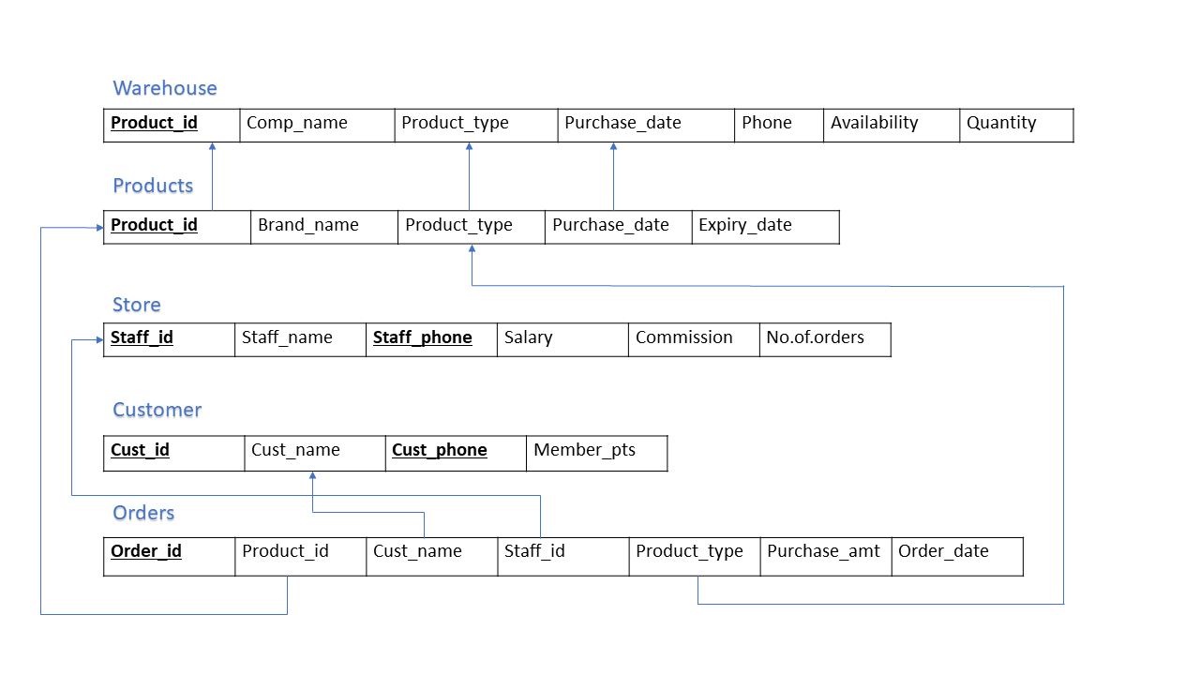

**Figure 3.1:** Schema Diagram

Figure 3.1 shows the schema of the project. It shows the primary key and the foreign key constraints of the tables. It contains entities and attributes that defines a schema. Schema represents the dependencies and the relations among the tables.

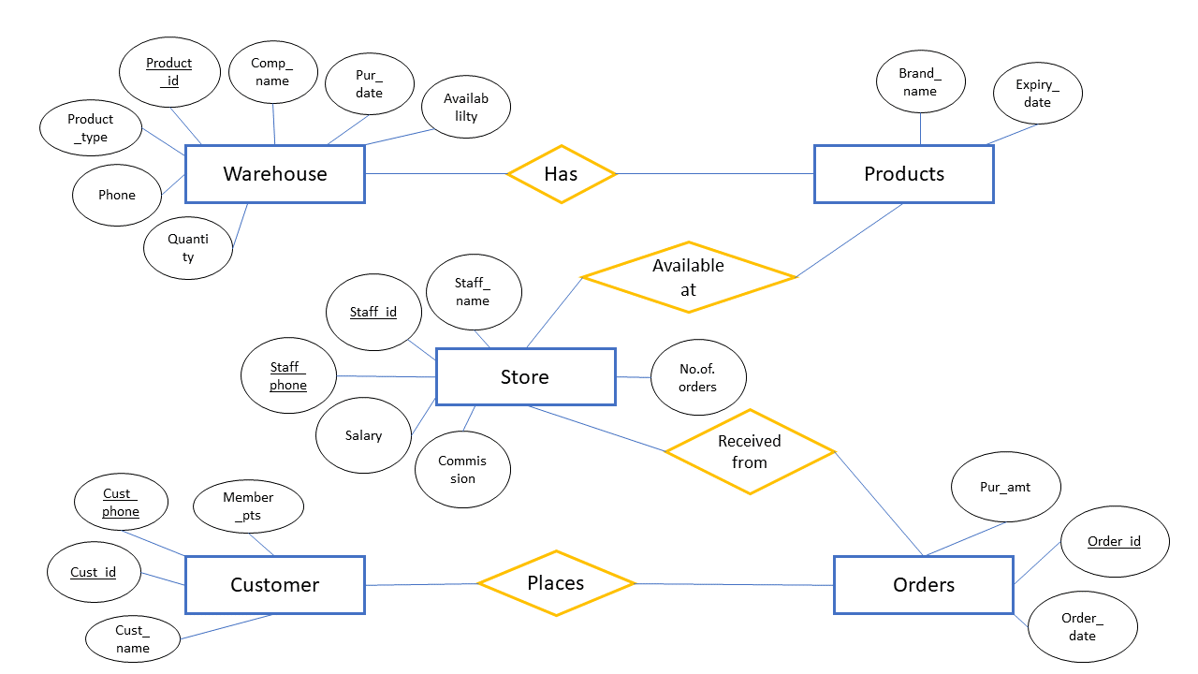

**Figure 3.2: Entity Relationship Diagram**

Figure 3.2 shows the tables, attributes and the relations between them. It gives an overall view of the tables used in the mini project. It gives information about how all the entities are related to each other through a relation.

## 3.3: What is Eclipse?

In the context of computing, Eclipse is an integrated development environment (IDE) for developing applications using the Java programming language and other programming languages such as C/C++, Python, PERL, Ruby etc.

The Eclipse platform which provides the foundation for the Eclipse IDE is composed of plug-ins and is designed to be extensible using additional plug-ins. Developed using Java, the Eclipse platform can be used to develop rich client applications, integrated development environments and other tools. Eclipse can be used as an IDE for any programming language for which a plug-in is available.

**3.4: Introduction to Mysql server**

Mysql Server is a full-featured Relational Database Management System (RDBMS) that offers a variety of administrative tools to ease the burdens of database development, maintenance and administration. In this article, we'll cover six of the more frequently used tools: Enterprise Manager, Query Analyzer, SQL Profiler, Service Manager, Data Transformation Services and Books Online.

**MODULES, TABLES AND THEIR DESCRIPTION**

* 1. **: Admin/Customer Module**

The admin module is used by admins to add New Data or to remove it. This also keeps the admins updated about Products and Staff Details. The Customer module is used by customer to view Products and their Order details.

### 3.6: Warehouse

This is used to keep detailed information about the products, product name, product type, date of purchase, availability of the product, quantity.

### 3.7: Products (Log Products)

This table is used by admin in order to enter Detailed information about the Products available in the Store, and customer can view only the available products.

### 3.8: Store Details

This table consists of information of the staff and their details such as name, salary, phone commission and no.of.orders.

### 3.9: Orders

This table is responsible for maintaining the records of the Orders placed by the customer and details like date of order, pricing, and the staff assigned to respective customer.

**3.10 Customer**

This table is used to maintain the records of customers such as customer id, name, phone

and their member points.

## 

## CHAPTER 4

## 

**RESULT**

### SNAPSHOTS

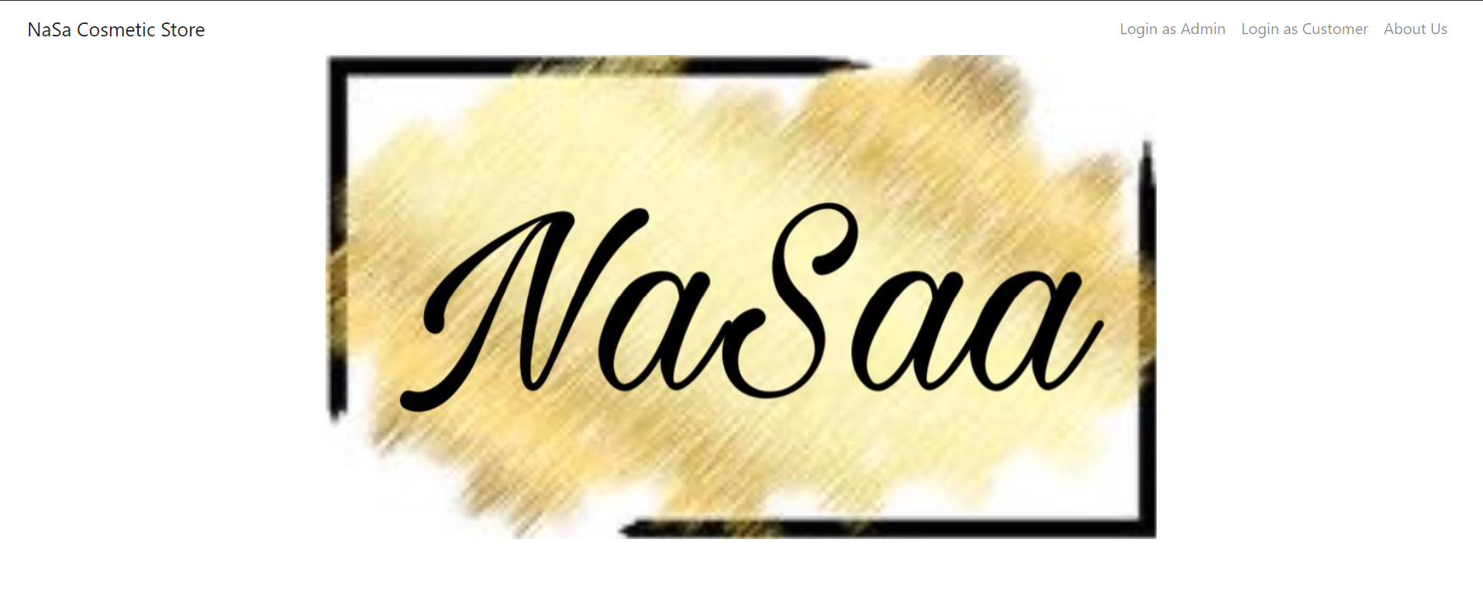 **Figure 4.2:** Homepage

This page appears when the user opens the website. Also called as the homepage page of the website. Here the user is provided with details of the website and to Navigate between all the tabs present

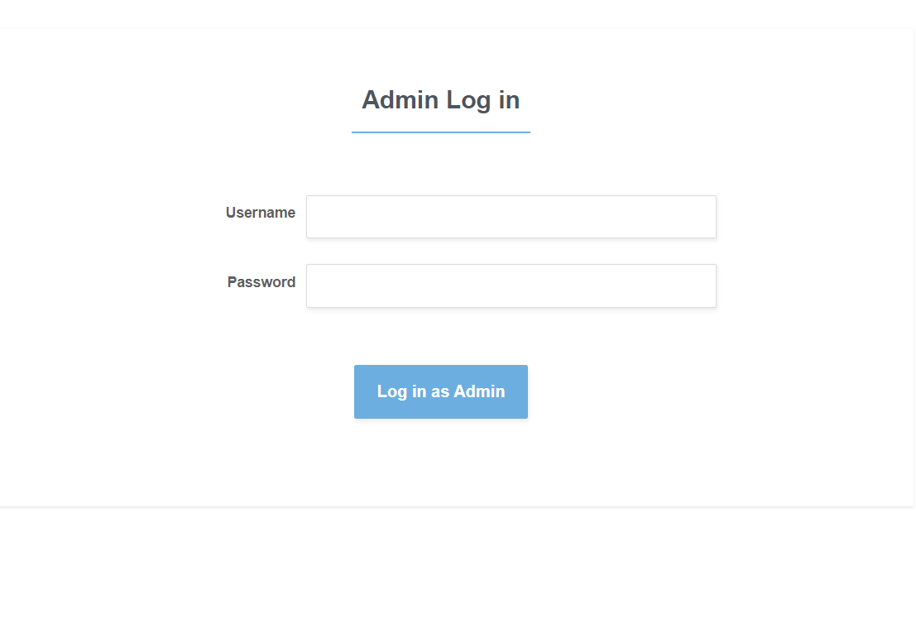

**Figure 4.3:** Admin Login Page

Admin Login. It asks the user/admin to provide username and password so that they can access the admin portal.

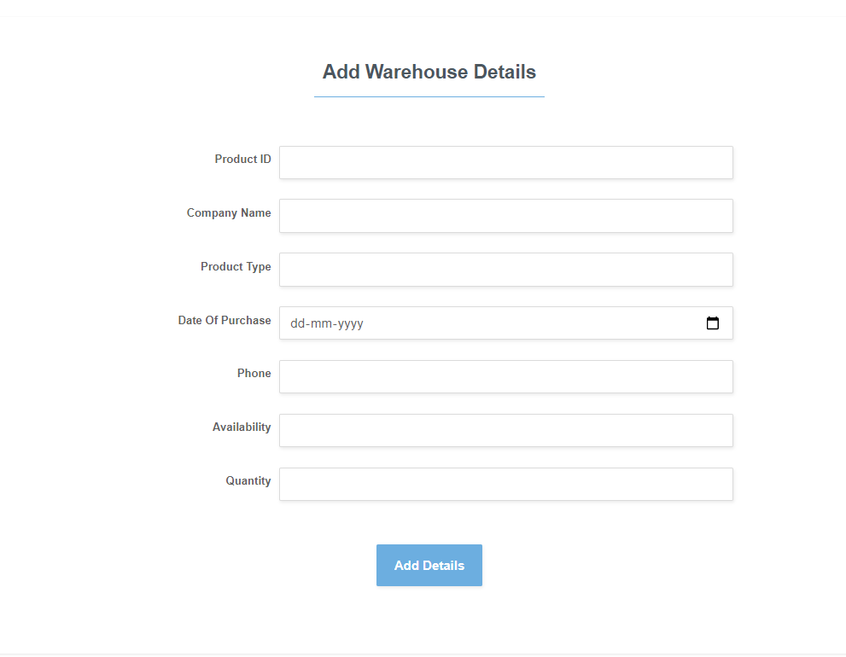

**Figure 4.4:** Adding Details to Warehouse Table

The admin can insert values to the tables, which will be displayed on the respective pages.

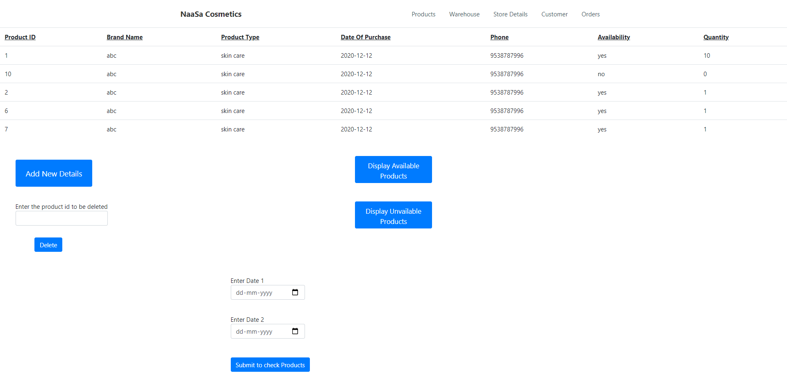

**Figure 4.5:** Warehouse Table

The values inserted by the admin will be displayed on their respective pages. The admin can delete the values and get a separate list of products based on their availability or order date.

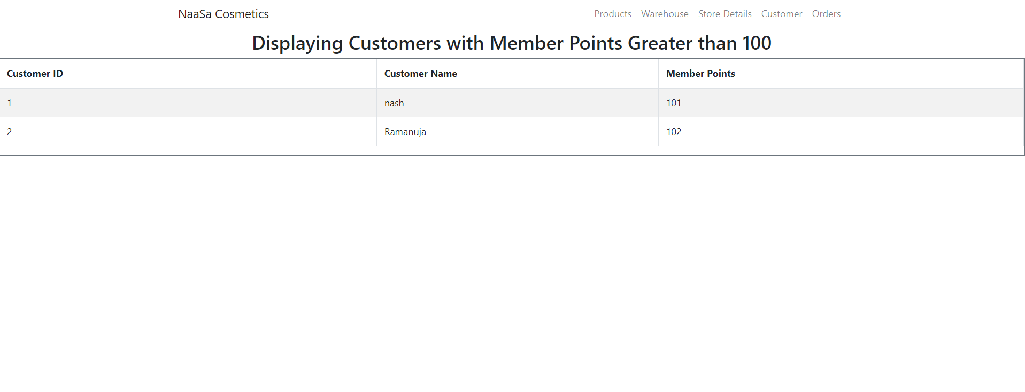

**Figure 4.6:** Displaying Premium Customers

A view created for easy retrieval of data. Which displays customers having member points greater than 100.

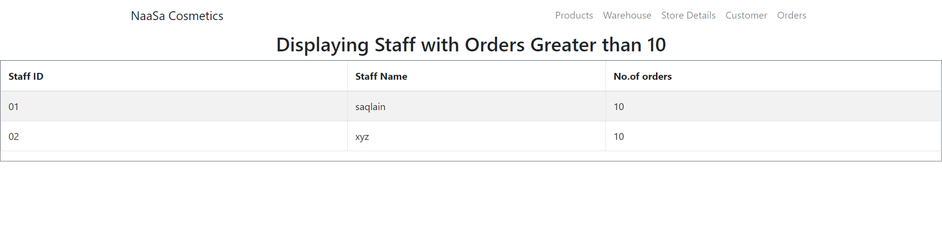

**Figure 4.7:** Displaying Elite Staff

A view created for easy retrieval of data. Which displays the list of staff who have taken up more than 10 orders.

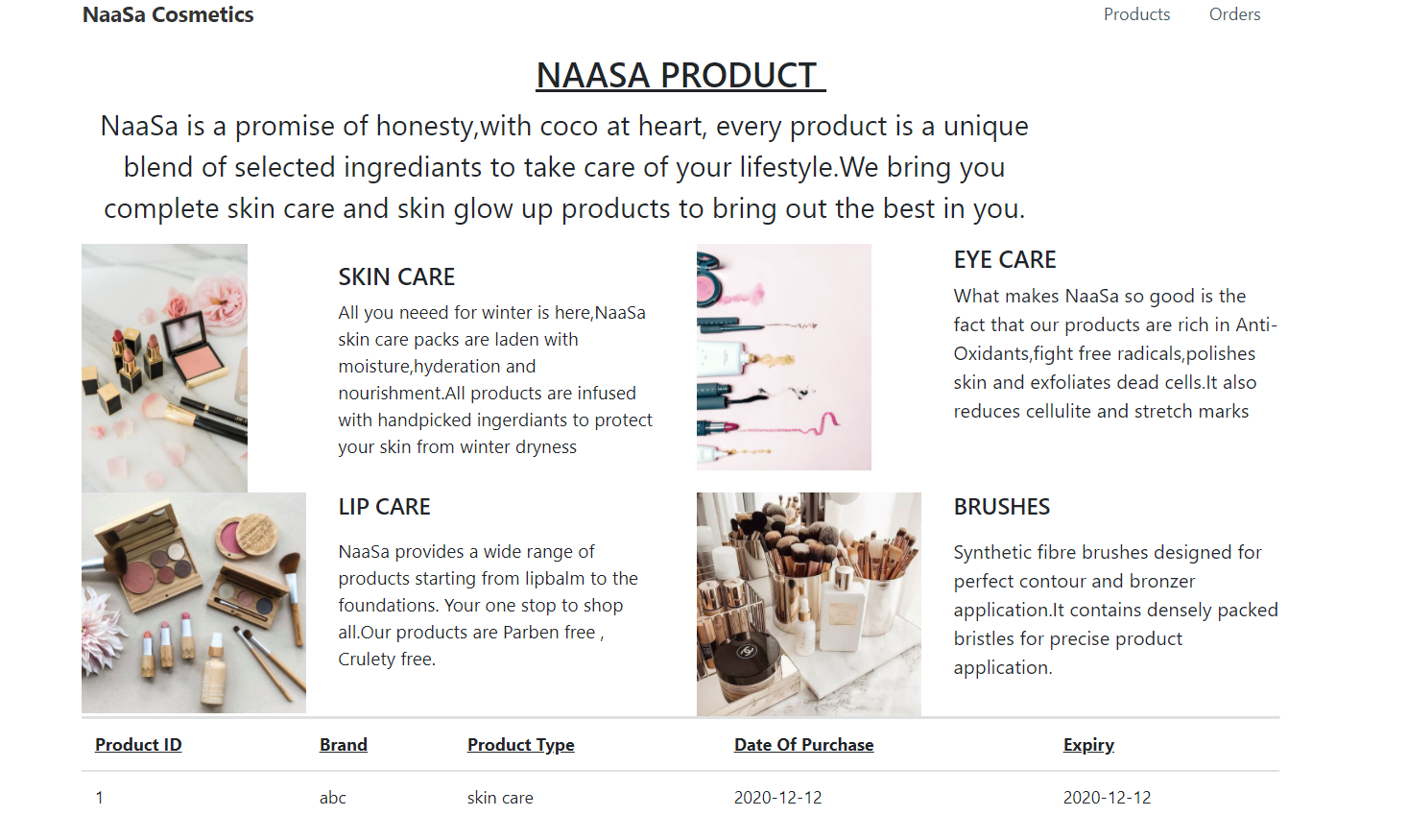

**Figure 4.8:** Products page

Fig 4.1.7 It shows the products page in customer view where user is only allowed to view the products with no option to alter the values.

**CONCLUSION**

**Conclusion**

After all the rigorous sittings and hours of hard labor, and getting to know new things which we did not know earlier, the project is finally completed and has really shaped in a satisfying way. The application stands out in most of its performance requirements and also has a very friendly and self-explaining user interface. Hopefully it will help the society in a meaningful and better way.

The application is very practical and simple to run and use. In today’s time where maintaining data and information in a safely and maintaining all the records correctly is a tedious job, this application can prove to be very handy to the user in terms of keeping track of All the activities in the Store. We hope the application ends up giving a nice experience to every user and has no fatal errors and any severe drawback. Any suggestion or feedback is eagerly awaited by us.

# REFERENCES

The references are as follows: -

* URL: https://bootstrapstudio.io/
* <URL:https://bootstrapstudio.io/https://www.eclipse.org/downloads/download.php?file=/oomph/epp/2020-12/R/eclipse-inst-jre-win64.exe>
* URL: <https://tomcat.apache.org/download-90.cgi>
* URL: <https://www.oracle.com/in/java/technologies/javase/javase-jdk8-downloads.html>